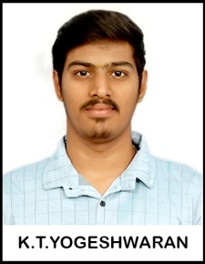

RESUME

Name : K T YOGESHWARAN
Address : 2/297B Saraswathi nagar, Kaithari Nagar,Nilaiyur,Madurai-625005
Mobile No :9597235456
Email Id :wyogesh322@gmail.com

Career Objectives:

- I am seeking challenging position which will help me to utilize my technical skill and provide me an opportunity to serve for the growth of the company.

Academic Details:

● B.Com - Sourashtra College With 70% from the Year of 2017-2020
● Higher Secondary – Sourashtra Higher Secondary School with 60% on 2017
● Senior Secondary - Sourashtra Higher Secondary School with 67% on 2015
Skills:

- Experienced Vb.Net Developer with 2+years of hands-on development experience.Specializes in developing user-friendly windows application and SQL server.
- Developed software application in VB.NET to improve customer experience and enhance office productivity
- Collaborated with a team of developers to design and implement VB.NET application
- Extensive knowledge in planning, scheduling, tracking, object-oriented development, and application architecture.
- Having good domain knowledge in C and C++.
- Strong Technical Skills in VB.NET, ASP.NET, C# and SQL Server, C# and Microsoft Technologies.

Software Used:
- Visual Studio.NET 2012, VB.Net, C#.Net, SQL Server2012, Crystal Report 9.0.

Personal Details:
Father Name : K.S.Tulasi Ram Mother Name : K.T. Jeyanthi
Date Of Birth : 17.06.2000
Gender : Male.
Marital status : No.

Language Known
  - Tamil : Read/write/speak.
  - English : Read/write/speak.
  - Sourashtra: speak
Nationality : Indian.
Location priority : Flexible for anywhere in India.

Declaration
I hereby declare that the above information is true to the best of my knowledge

Place: Madurai
Date: (K.T. Yogeshwaran)

