

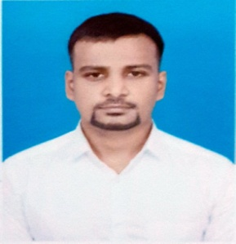HARIRAMESH A

# SUMMARY:

Support cum Developer with 2 years of working experience in SQL Server and ASP. NET. Dynamic professional with experience in development and implementation skills with Strong analytical skills. To establish me over the long-term with an exciting organization where there is an opportunity for growth and advancement.

# EXPERIENCE:

## .NET/SQL Developer

Over 2 years of experience as .NET developer. Skilled at Analysis, design, support, development and performance tuning of application using .NET/SQL server for database.

Familiarity in Writing  **Stored Procedures and functions** using SQL Server 2005

Good knowledge of Query Optimizer, Execution Plans, and Indexes. Handled errors for the ease of debugging and displaying the error messages in the application.

Have used SQL queries optimally using **Aggregate functions ,Table Joins , group by, order by** commands.

Also Have exposure on AWS -EC2, VPC, Load balancer and firewall.

# EDUCATION:

Bachelor of Engineering-EEE

Jaya Engineering College- Thiruninravur

# EMPLOYMENT HISTORY:

Pace Software Solutions(Software):

(Nov 1st 2022- Apr 30th 2024)

PDCS(Software & Non Software):

Jan 2019-Aug2022

# CONTACT:

## Email:

[hariramesharunasalam@gmail.com](mailto:hariramesharunasalam@gmail.com)

## Phone:+918610516580

**LinkedIn:**

<https://www.linkedin.com/in/hariramesh-arunasalam-b55558179/>

**Location:** KK Nagar**,** Chennai

# SKILLS:

**\***SQL Server (2005, 2008, 2012, 2019)

*ASP. NET (3.5 and 2.0),

{For attendance application we use 2.0,

For other applications we use ASP.NET core}

* IDE: Visual Studio 2005,2017, 2022

*C#, VB.NET

* Exposure on Angular JS (1.6.4)

* Working Knowledge in English, Thamizh, Hindi

with ability of Read/Write/Speaking .